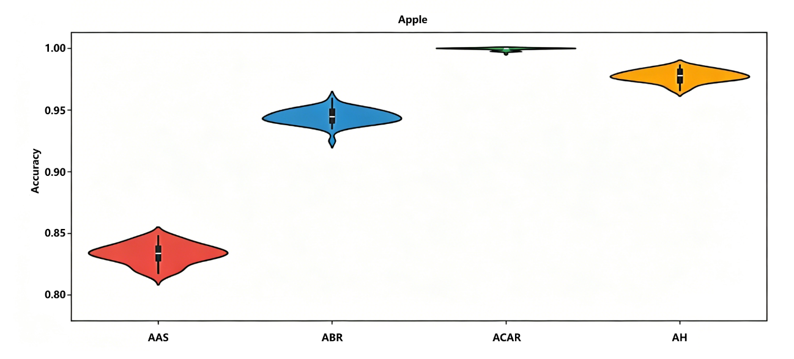Figure 4.10 Violin Plot of Apple Disease Identification Accuracy

